AGENDA

1. UPDATE ON TIMELINES / LAUNCH PLAN

2. AGREE CHANGES TO RANGING SYSTEM SCREENS
- What the system looks like (screen shot)
- Where we are with the different versions of the Ranging System & what we are reviewing today
- Overview of system – what we are proposing to change
- Details on screens we are proposing to change
- Other changes
- Outstanding questions
- Enhanced capability for out of cycles - options

2. AGREE CHANGES TO RANGING SYSTEM SCREENS

What the system looks like
See Appendix.

Where we are with the different versions of the Ranging System & what we are reviewing today
BSD 4 | Basic functionality & screens
 | Signed off June 2005. Developed and currently in test
BSD 15 | Enhanced functionality – largely extra MI (margin & waste), Sales History period selection, limited changes to screens.
 | Finalising BSD, development started
BSD 18 | Enhanced capability for out of cycles, Live Ranges Workbook, and some other enhancements
 | Gathering requirements / studying options

Today we want to focus on agreeing the changes to screens contained in BSD 15 (includes some changes arising out of Customer Acceptance Testing) and the options for enhanced capability on out of cycles (BSD 18).

Overview of system – what we are proposing to change
Workbook overview

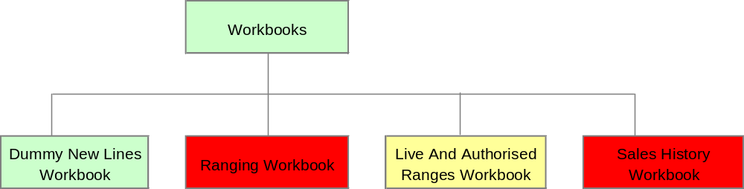
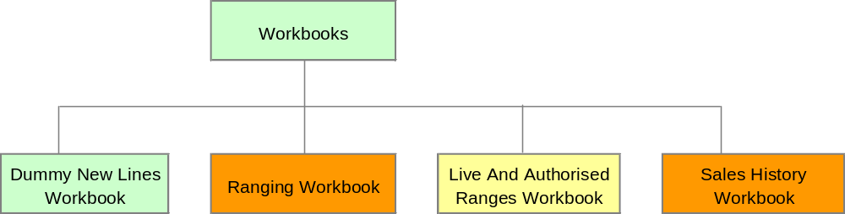
- The Dummy New Lines Workbook is used to set-up and maintain dummy products and to link dummy products to CW products.
- The Ranging Workbook is used to perform range changes.
- The Live and Authorised Ranges Workbook is used to view the current live range for any Merchandising Group
- The Sales History Workbook is used to change the history period for the performance data.

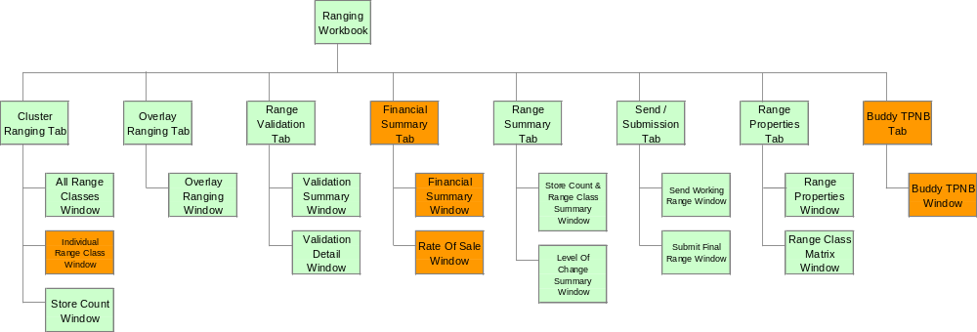
Ranging workbook

The Ranging workbook is organised as a number of tabs, which are designed to lead the Commercial user through the ranging process.
- The Cluster Ranging Tab contains three windows:
- The All Range Classes Window, which is used to make core range changes for each Store Cluster and Range Class using a TPNB centric viewpoint (i.e. shows how a TPNB is ranged across all Range Classes).
- The Individual Range Class Window, which is used to make core range changes for each Store Cluster and Range Class using a Range Class centric viewpoint (i.e. shows how TPNBs are ranged within a specific Range Class). We are planning add margin and waste to the sales information on this screen.
- The Store Count Window, which shows information about the number of stores allocated to each Range Class within a Store Cluster. This window is linked to the ranging windows so that it always shows information for the Store Cluster currently being ranged.
- The Overlay Ranging Tab contains one window:
- The Overlay Ranging Window, which is used to specify TPNBs to overlay the core range for each Store Cluster and Range Class.
- The Range Validation Tab contains two windows:
- The Validation Summary Window, which shows the number of errors in each Store Cluster.
- The Validation Detail Window, which shows details of any errors or warnings identified when the system checks the ranges.
- The Financial Summary Tab contains two windows:
- The Financial Summary Window which shows As Is v To Be Financial Information
- The Rate of Sale Window which shows the rate of sale of each line in each cluster / space break combination
- The Range Summary Tab contains two windows:
- The Store Count And Range Class Summary Window, which shows the lowest Range Class for each product in each Store Cluster, both As Is and To Be, and the number of stores the product will be ranged in
- The Level Of Change Summary Window, which shows the number of products in the range for each Store Cluster, both As Is and To Be, the number of deleted products, the number of changes made and the percentage change to the range by Space Break by Cluster.
- The Send / Submission Tab contains two windows:
- The Send Working Range Window, which can be used to send ranges that are still under construction to Merchandising
- The Submit Final Range Window, which is used to submit the final ranges to Merchandising.
- The Range Properties Tab contains two windows:
- The Range Properties Window, which shows general information about the ranges in the ranging workbook, such as the type of range change, e.g. Refresh, the effective dates for the range changes and the Sales History period used.
- The Store Count Matrix Window, which shows store count by Range Class within each Store Cluster and a total for all Store Clusters.
- The Buddy TPNB Tab contains one window:
- The Buddy TPNB Window, which allows a buddy TPNB to be selected for a product. The sales history of the buddy TPNB is then used as the basis for the sales forecast for the (new) product.

Details on screens we are proposing to change

Individual Range Class window
Used to make detailed ranging decisions with financial information to support. Now includes margin & waste. (Aggregates up at sub-group and merch group level.)
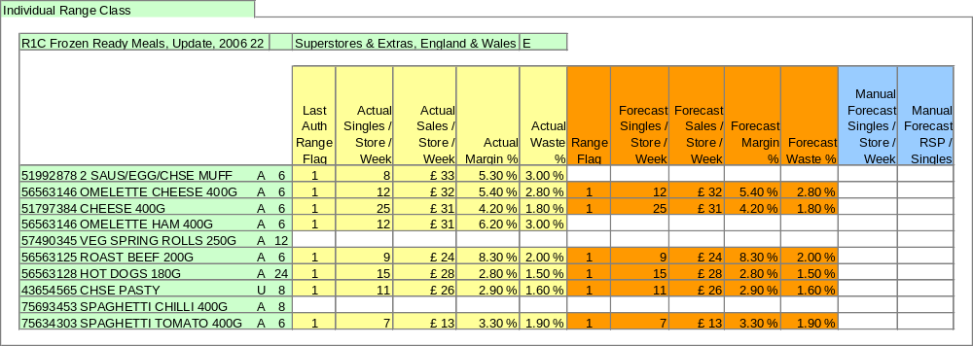

Financial Summary window
Gives As Is v To Be financial information based on impact of range changes on sales, margin mix, & waste. (Aggregates up at sub-group and merch group level.)

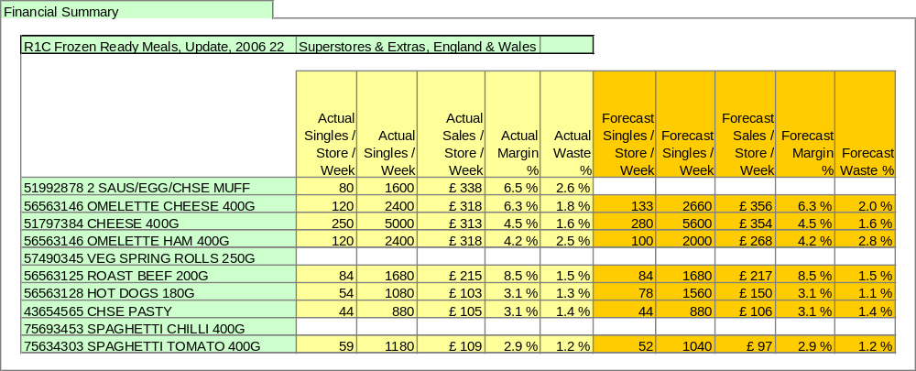

Rate of Sale window
Gives rate of sale by space break / cluster on one screen.

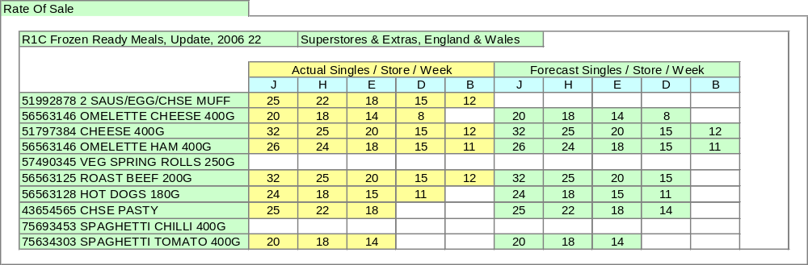

Buddy TPNB window
Used to forecast sales for new lines based on “buddy products”. User can choose same buddy for all clusters, or different buddies in different clusters.

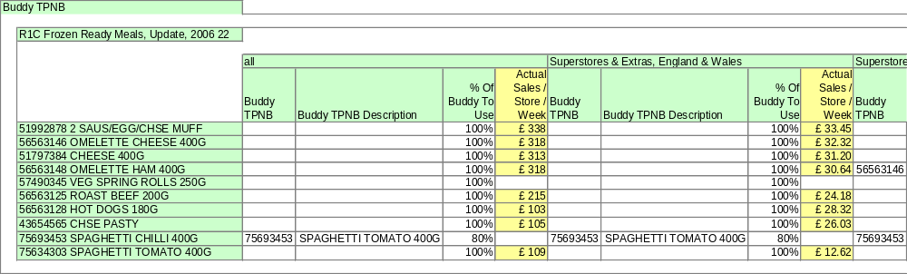

Sales History Workbook
Allows user to select a sales history period as alternative to the rolling 52 week default.

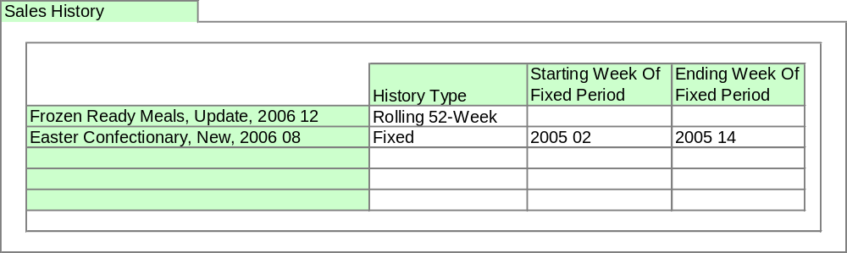

Other changes
We are planning to include the following in the enhancements to the Ranging System. However, none of them will be shown on the default screens – they will be available for more advanced users to access by changing the default screens.
- Sales forecast shown by case size
- Tesco & supplier brand information
- Diamond lines

The Store Count & Range Class Summary Window will also be enhanced to allow the user to view the total number of stores a product is ranged in including supplementary merchandising groups. This may be a separate workbook.

Outstanding questions
- Any desire to be able to manually enter Margin & Waste forecasts. Currently margin is based only on historic margin for existing lines and CW margin for new lines; Waste would probably be based on the buddy product used for the sales forecast. It is possible to include the ability to manually over-ride these, but would introduce additional complexity (and could focus users overly on financial criteria)
- What desire is there to use the Live & Authorised Ranges workbook as a performance review tool? Currently designed only to replicate basic range information in the Ranging Workbook (Ranging windows, Store Count & Range Class Summary Window etc), but could be developed to include sales pre and post range change.

Enhanced capability for out of cycles, etc (BSD 18)
See separate paper

